Azure Administration with PowerShell

Project Overview
This project documents a hands-on Azure administration workflow using Azure Cloud Shell, PowerShell, and a Linux virtual machine. The lab demonstrates how to create cloud resources, deploy a VM, verify network information, connect remotely through SSH, perform basic Linux administration, install PowerShell inside the VM, and clean up resources to avoid unnecessary charges.

Tools and Environment
- Microsoft Azure Portal
- Azure Cloud Shell
- PowerShell / Az PowerShell module
- Ubuntu Linux virtual machine
- SSH client
- Visual documentation with screenshots

Step-by-Step Workflow

Step 01 - Sign in to Azure Portal
Log in to the Azure Portal and confirm that your Azure account/subscription is available. This is the starting point for all cloud administration work in the lab.
Screenshot should show: Azure Portal home page or dashboard after login. Blur your email/account name before publishing.
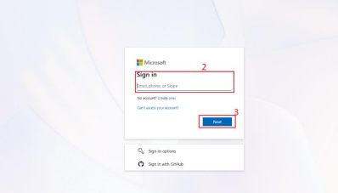

Step 02 - Open Azure Cloud Shell
Open Azure Cloud Shell from the Azure Portal and choose PowerShell. Cloud Shell allows Azure commands to be executed directly from the browser without installing tools locally.
Screenshot should show: Cloud Shell opened at the bottom of the Azure Portal.
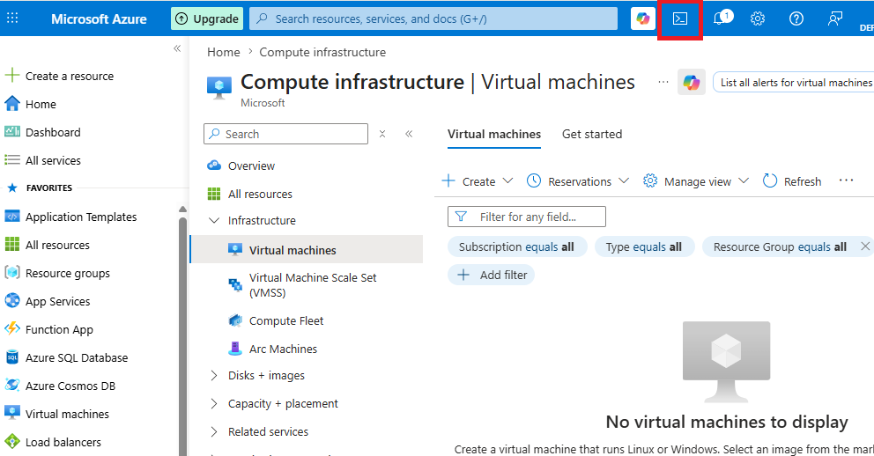
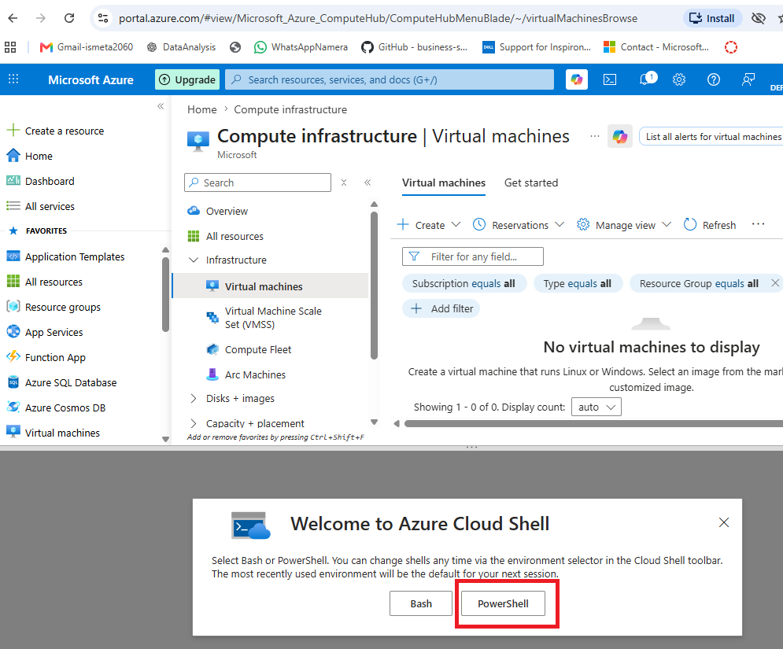
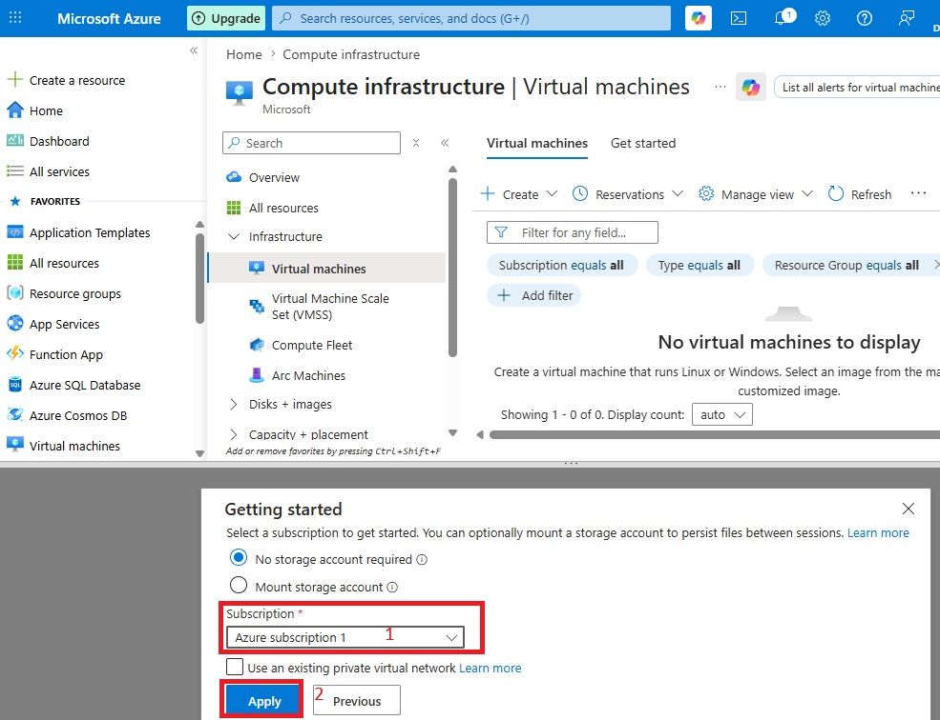
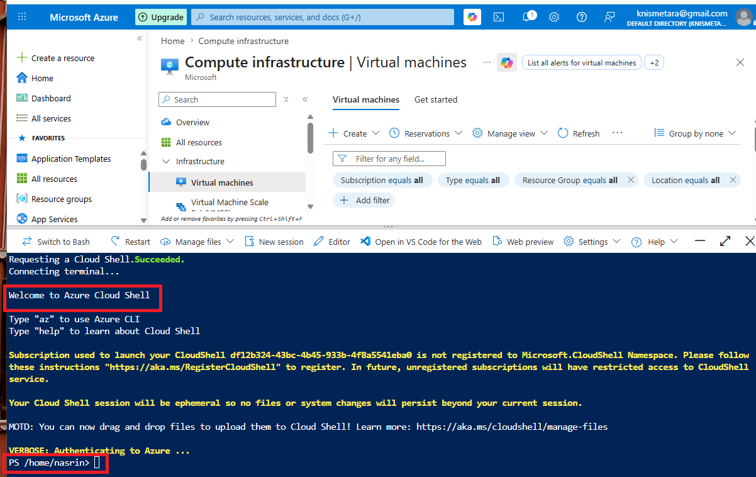

Step 03 - Create a Resource Group
Create a resource group to organize all lab resources. A resource group is a logical container for the VM, network interface, disk, public IP, and related Azure resources.
Command used:
New-AzResourceGroup -Name 'PowerSheLab' -Location 'EastUS'Screenshot should show: command output confirming the resource group was created successfully. Blur subscription/resource IDs if visible.
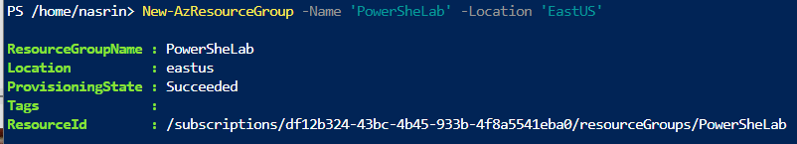

Step 04 - Create the Linux Virtual Machine
Deploy an Ubuntu Linux VM using Azure PowerShell. This creates the VM and supporting resources such as networking and public IP settings.
Command used:
New-AzVM `
-ResourceGroupName 'PowerSheLab' `
-Name 'LinuxVM' `
-Location 'EastUS' `
-Image Ubuntu2204 `
-Size Standard_B1s `
-PublicIpAddressName myPubIP `
-OpenPorts 80
Screenshot should show: the New-AzVM command or the VM creation process. Do not publish passwords.
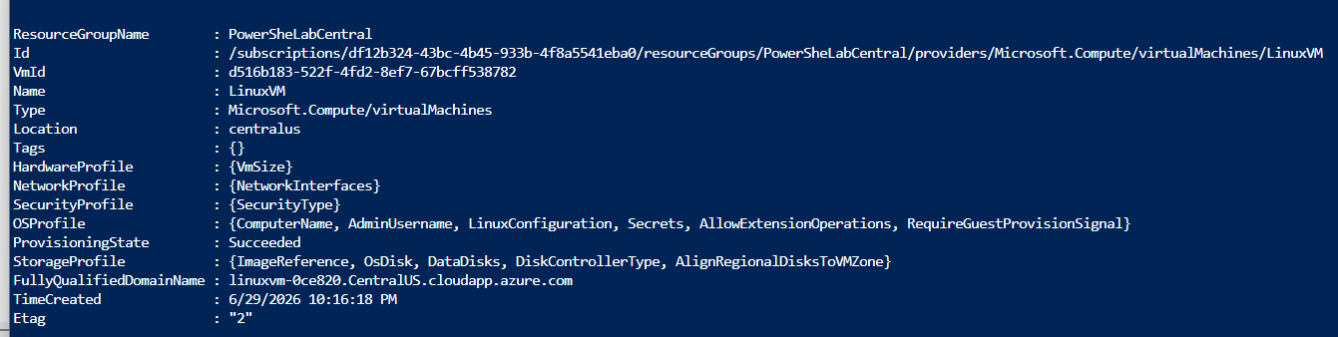

Step 05 - Confirm VM Creation
After the VM finishes deploying, review the output in Cloud Shell or the VM resource page. This confirms that the virtual machine was created and is running.
Screenshot should show: VM provisioning succeeded or the VM listed in Azure. Blur resource IDs and public IP if needed.
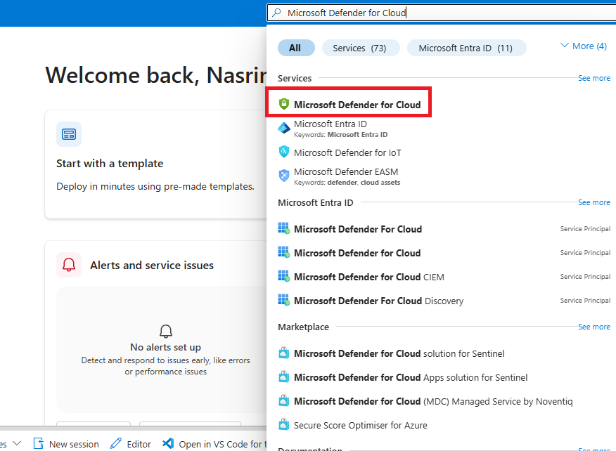

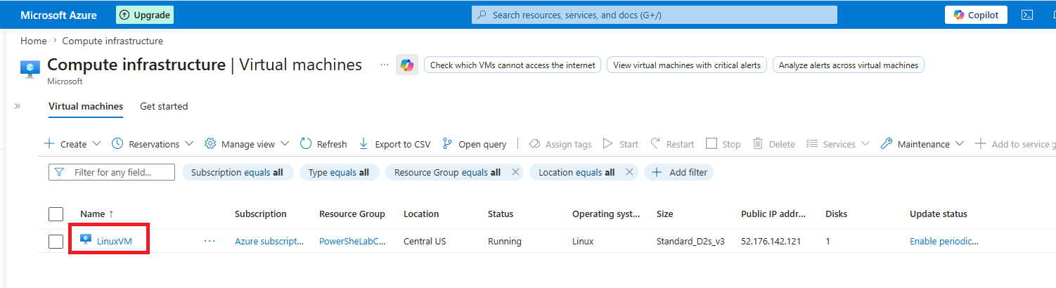

Step 06 - Locate the VM in Azure Portal
Use the Azure search bar to find Virtual Machines and open the Linux VM created for the lab. This verifies the VM exists in the Azure Portal.
Screenshot should show: Virtual Machines page with LinuxVM listed. Blur subscription information.


Step 07 - Review VM Overview and Public IP
Open the VM overview page and review important details such as status, region, operating system, size, and public IP address.
Screenshot should show: VM overview page. Blur public IP address and subscription ID before publishing.
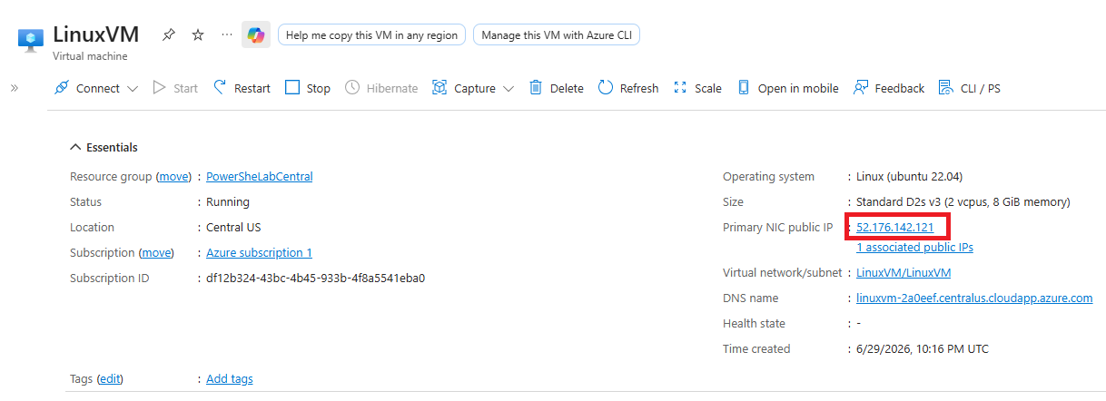

Step 08 - Verify Public IP Address with PowerShell
Use Azure PowerShell to retrieve the VM public IP address from Cloud Shell. This confirms the IP used for remote SSH access.
Command used:
Get-AzPublicIpAddress -Name myPubIP -ResourceGroupName PowerSheLabCentral | Select-Object IpAddress
Screenshot should show: command output displaying the IP address. Blur the IP address before publishing publicly.
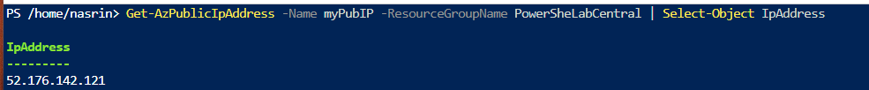

Step 09 - Connect to the VM Using SSH
Connect to the Linux VM through SSH using the VM username and public IP address. This demonstrates remote administration access.
Command used:
Get-AzNetworkSecurityGroup -ResourceGroupName PowerSheLabCentral

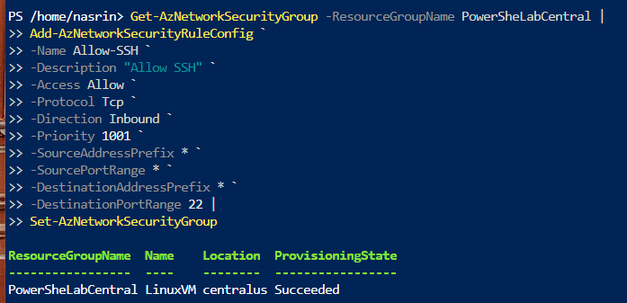

ssh username@public-ip-address
Screenshot should show: SSH command and successful connection prompt. Blur username/IP if you prefer.
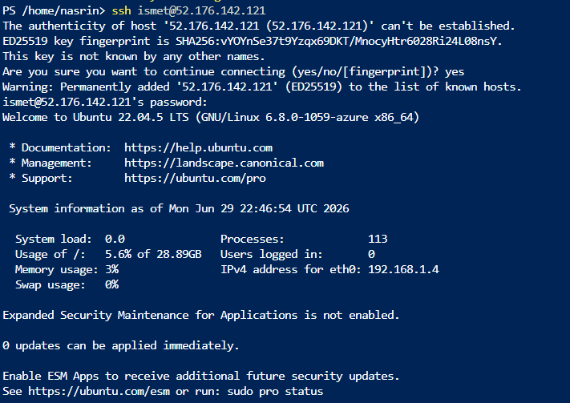
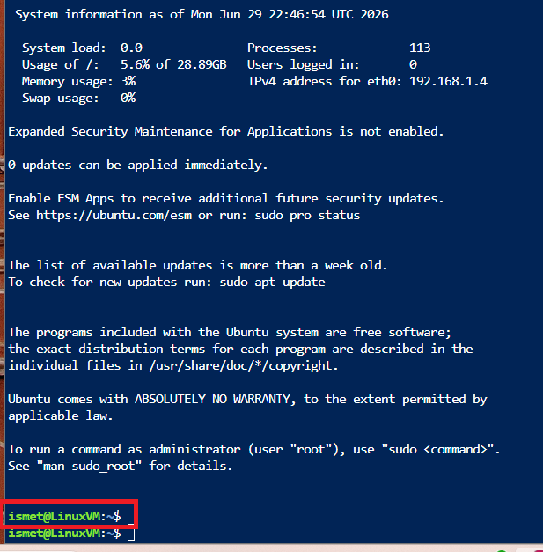

Step 10 - Confirm Successful Linux Login
After authentication, confirm that the terminal prompt changes to the Linux VM environment. This shows that remote access is working.
Screenshot should show: Ubuntu welcome message or Linux shell prompt such as user@LinuxVM. Do not show passwords.


Step 11 - Update Linux Package Lists
Run the package update command to refresh available package information on the Linux VM. This is a common administrative maintenance task.
Command used:
sudo apt-get update
Screenshot should show: apt update command completed successfully.
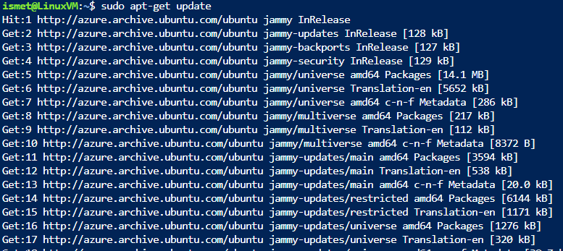

Step 12 - Upgrade Installed Packages
Run the upgrade command to apply available package updates. Accept prompts only when appropriate in your lab environment.
Command used:
sudo apt-get upgrade
Screenshot should show: apt upgrade command and completion or prompt confirmation.
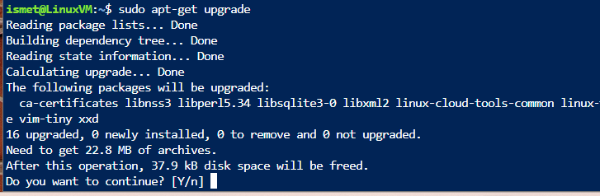

Step 13 - Install Required Linux Packages
Install required packages such as wget before downloading additional software. This supports later installation steps.
Command used:
sudo apt-get install -y wget
Screenshot should show: wget installation command completed successfully.
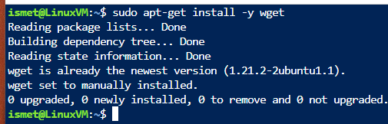

Step 14 - Download PowerShell Package
Download the PowerShell package file for Linux using wget. This prepares the VM for PowerShell installation.
###################################
# Prerequisites
# Download the PowerShell package file
wget https://github.com/PowerShell/PowerShell/releases/download/v7.4.0-preview.5/powershell-preview_7.4.0-preview.5-1.deb_amd64.deb
Screenshot should show: wget download progress or completed package download.
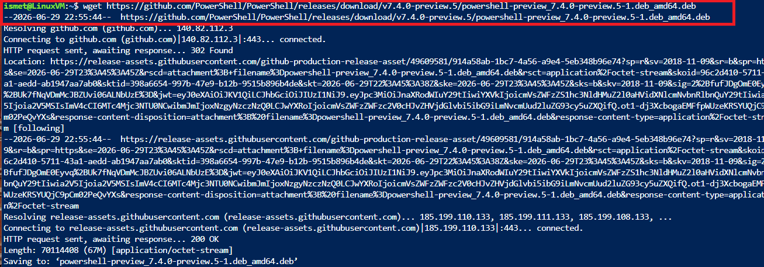

Step 15 - Install PowerShell on the VM
Install the downloaded PowerShell package and resolve any missing dependencies. This demonstrates software installation and Linux administration.
Command used:
sudo dpkg -i powershell-preview_7.4.0-preview.5-1.deb_amd64.deb
Screenshot should show: wget download progress or completed package download.
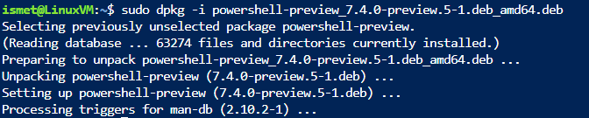

# Resolve missing dependencies and finish the install (if necessary)
sudo apt-get install -f
# Delete the downloaded package file
rm powershell-preview_7.4.0-preview.5-1.deb_amd64.deb

Step 16 - Start PowerShell on Linux
Start PowerShell inside the Linux VM to confirm that installation succeeded.
Command used:
pwsh-preview
Screenshot should show: PowerShell prompt running inside the Linux VM.
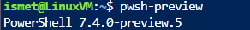

Step 17 - Exit the VM Session
Exit PowerShell and SSH after confirming the lab work is complete. This closes the remote administration session.
Command used:
exit
Screenshot should show: exit command or return to Cloud Shell prompt.
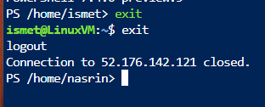

Step 18 - Stop the Virtual Machine
Stop the VM when it is no longer needed to reduce usage and avoid unnecessary charges.
Command used:
az vm stop --resource-group PowerSheLabCentral --name LinuxVM
Screenshot should show: VM stop command or Azure Portal showing stopped/deallocated status.
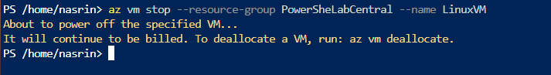

Step 19 - Delete the Resource Group
Delete the resource group to remove all resources created for the lab. This is an important cloud cost-control practice.
Command used:
az group delete --name PSLab --yes --no-wait
Screenshot should show: resource group deletion command or confirmation that resources are removed.

Step 20 - Verify Cleanup
Confirm that the lab resources were deleted or no longer appear in the resource group. This final check prevents unwanted billing.
Screenshot should show: Resource group deleted, no lab resources listed, or Azure cleanup confirmation.
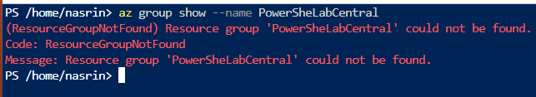

Screenshot Order Checklist
Order | Screenshot Name | What It Should Show
01 | Screenshot 01 - Sign in to Azure Portal | Azure Portal home page or dashboard after login. Blur your email/account name before publishing.
02 | Screenshot 02 - Open Azure Cloud Shell | Cloud Shell opened at the bottom of the Azure Portal.
03 | Screenshot 03 - Create a Resource Group | command output confirming the resource group was created successfully. Blur subscription/resource IDs if visible.
04 | Screenshot 04 - Create the Linux Virtual Machine | the New-AzVM command or the VM creation process. Do not publish passwords.
05 | Screenshot 05 - Confirm VM Creation | VM provisioning succeeded or the VM listed in Azure. Blur resource IDs and public IP if needed.
06 | Screenshot 06 - Locate the VM in Azure Portal | Virtual Machines page with LinuxVM listed. Blur subscription information.
07 | Screenshot 07 - Review VM Overview and Public IP | VM overview page. Blur public IP address and subscription ID before publishing.
08 | Screenshot 08 - Verify Public IP Address with PowerShell | command output displaying the IP address. Blur the IP address before publishing publicly.
09 | Screenshot 09 - Connect to the VM Using SSH | SSH command and successful connection prompt. Blur username/IP if you prefer.
10 | Screenshot 10 - Confirm Successful Linux Login | Ubuntu welcome message or Linux shell prompt such as user@LinuxVM. Do not show passwords.
11 | Screenshot 11 - Update Linux Package Lists | apt update command completed successfully.
12 | Screenshot 12 - Upgrade Installed Packages | apt upgrade command and completion or prompt confirmation.
13 | Screenshot 13 - Install Required Linux Packages | wget installation command completed successfully.
14 | Screenshot 14 - Download PowerShell Package | wget download progress or completed package download.
15 | Screenshot 15 - Install PowerShell on the VM | dpkg installation and dependency resolution commands completed.
16 | Screenshot 16 - Start PowerShell on Linux | PowerShell prompt running inside the Linux VM.
17 | Screenshot 17 - Exit the VM Session | exit command or return to Cloud Shell prompt.
18 | Screenshot 18 - Stop the Virtual Machine | VM stop command or Azure Portal showing stopped/deallocated status.
19 | Screenshot 19 - Delete the Resource Group | resource group deletion command or confirmation that resources are removed.
20 | Screenshot 20 - Verify Cleanup | Resource group deleted, no lab resources listed, or Azure cleanup confirmation.

README for GitHub

Azure Administration with PowerShell

Overview
This project documents an Azure administration workflow using Azure Cloud Shell, PowerShell, and an Ubuntu Linux virtual machine. It demonstrates resource group creation, VM deployment, public IP verification, SSH remote access, Linux administration, PowerShell installation, and cloud resource cleanup.

Skills Demonstrated
- Azure Portal navigation
- Azure Cloud Shell and PowerShell
- Resource group and VM administration
- SSH remote access
- Linux package management
- PowerShell installation on Ubuntu
- Cloud cleanup and cost-control practices

Important Note
Screenshots included in this repository are my own lab screenshots. Sensitive information such as subscription IDs, public IP addresses, usernames, emails, and billing details should be blurred before publishing.

Final Publishing Checklist
- Only your own screenshots are included.
- No original course handout pages are included.
- No passwords or secrets are visible.
- Subscription IDs, tenant IDs, usernames, public IPs, emails, and billing details are blurred.
- README.md is added to GitHub.
- PDF version is added only if it does not expose sensitive data.

